**Asteroids Design Document**

**Screens-**

**1. Help:**

2-4 pages of text,

Contains game controls, game rules

Return to main menu button

Optional watch credits early

Total Game Progress, Stats

Instructions for each screen

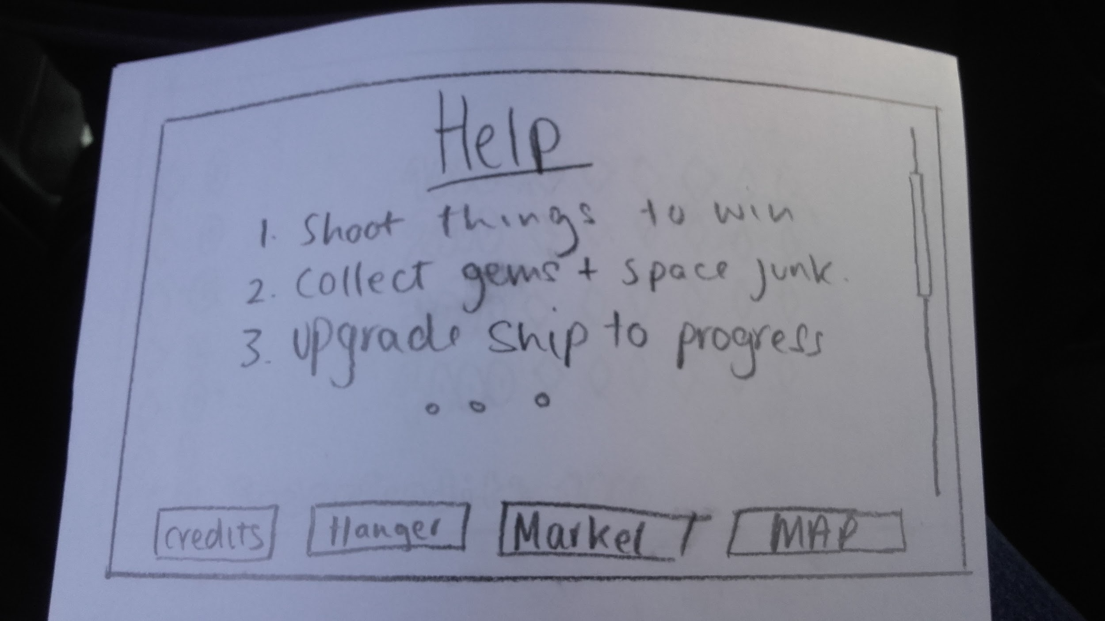

**Game Controls:**

**<Space>** to shoot

**<Left>** turn player left

**<Right>** turn player right

**<Esc>** Bring up pause screen

**<Enter>** (While in menu) will re-commence play

**<Alt>** Bring up shields

**<Shift>** Accelerate the player in the facing direction

**Game Rules:**

Shoot player ships to get scrap metal

Shoot asteroids to get gems, big gems worth two, small worth one

Drive into item to collect

**Game Screens:**

In the Hangar menu you can upgrade your ship to make it faster, stronger or have a larger capacity to hold items. There are four optional upgradable parts. To select a part to upgrade, just hover the mouse over the area and click to select. This will bring up three-four upgrades selecting one will give access to the player to purchase another and so on. After the player has fully upgraded the whole ship it will

show the upgrades in white. Both credits and scrap are used to upgrade the ship.

In the map menu you can only select planets that are in colour. The player will unlock more planets as their ship is upgraded. Once you’ve clicked on an unlocked planet it will bring you straight into gameplay.

In the Market menu there are four options to exchange gems for credits. When one option is selected, it will take the specified number of gems and give the player the appropriate amount of credits, then the market list is updated to allow for gameplay to be more enticing and difficult for the player.

**2. Upgrade:**

Use a bigger version of the ship to show upgrades

3-4 Individual names for each of the four upgrades on the ship

Parts laser, exhaust, main body, fans (faster)

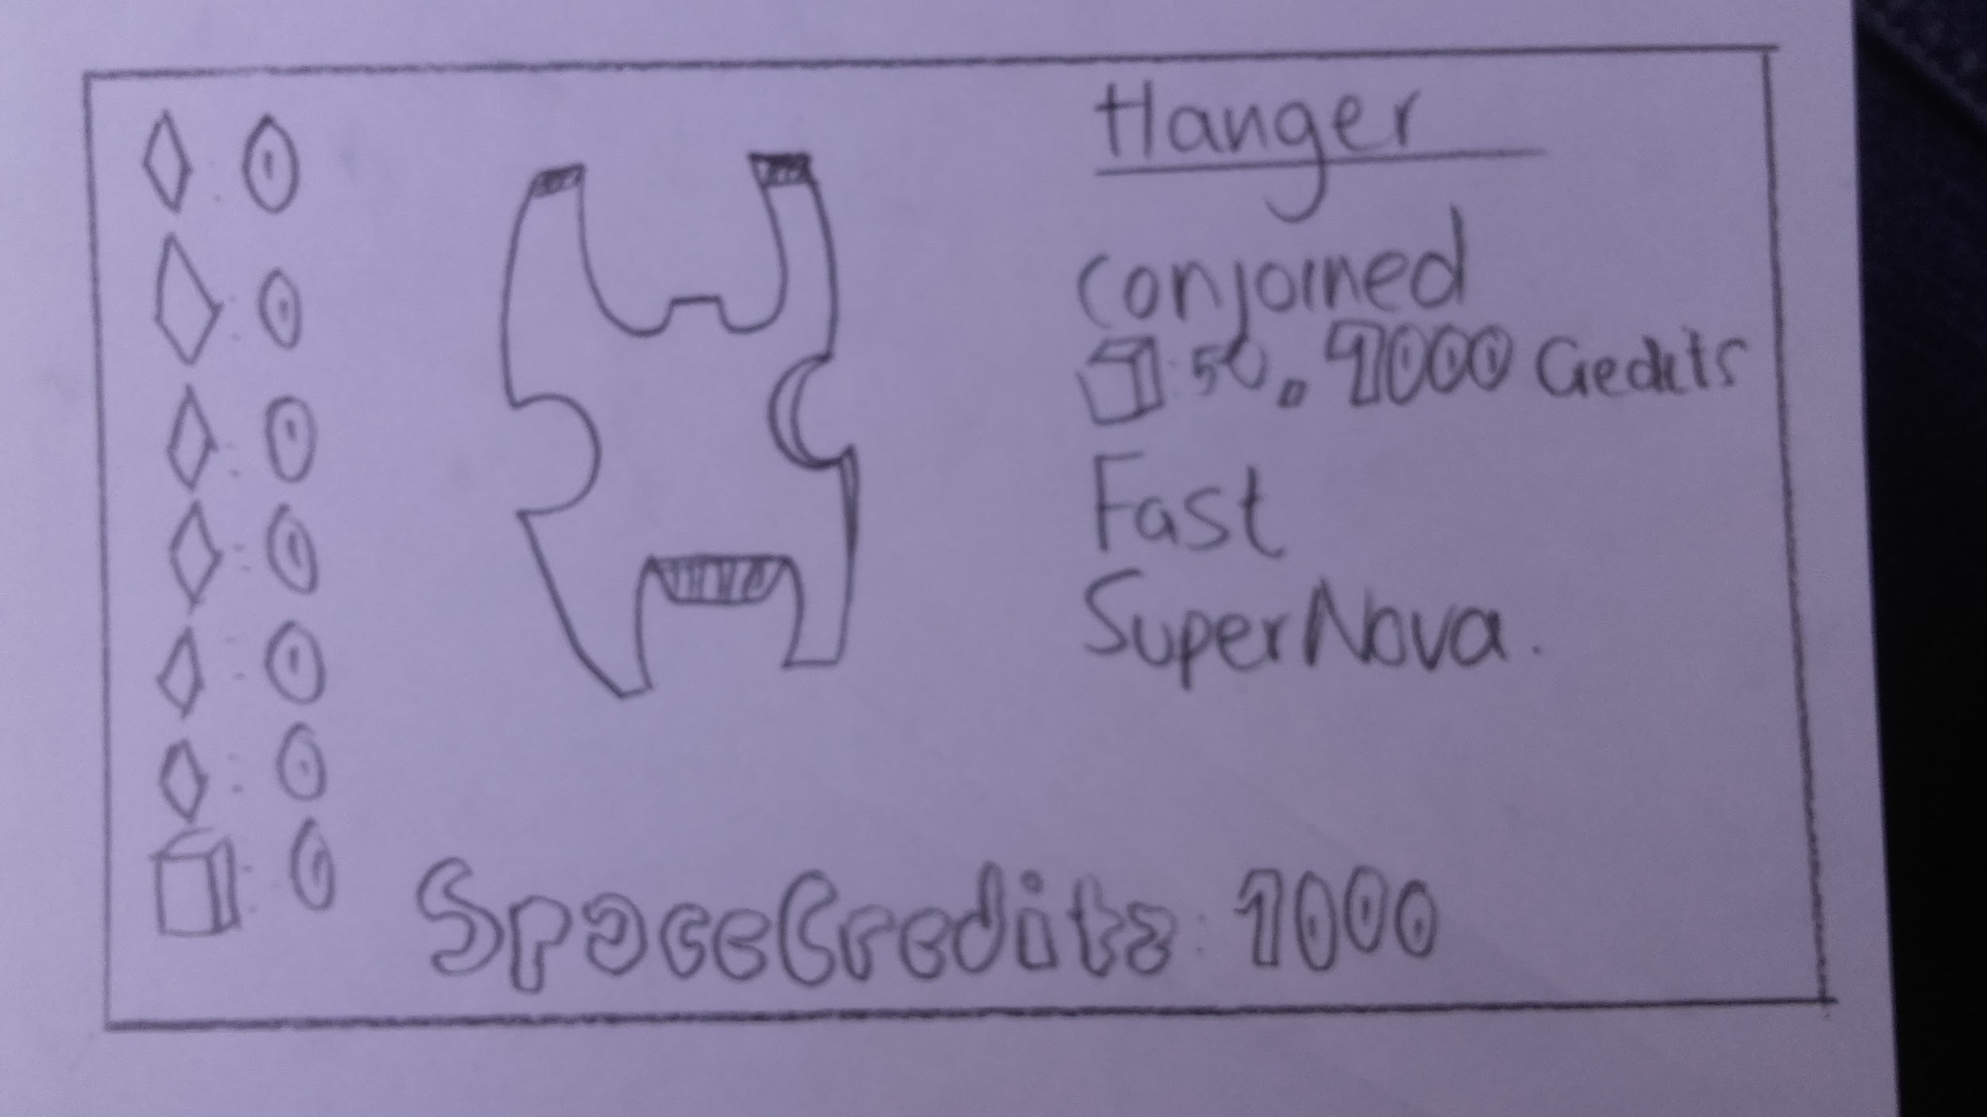

**3. Menu screen:**

Contain all the screens and an exit game option

Will use the same starting screen

Clickable text to enter a screen

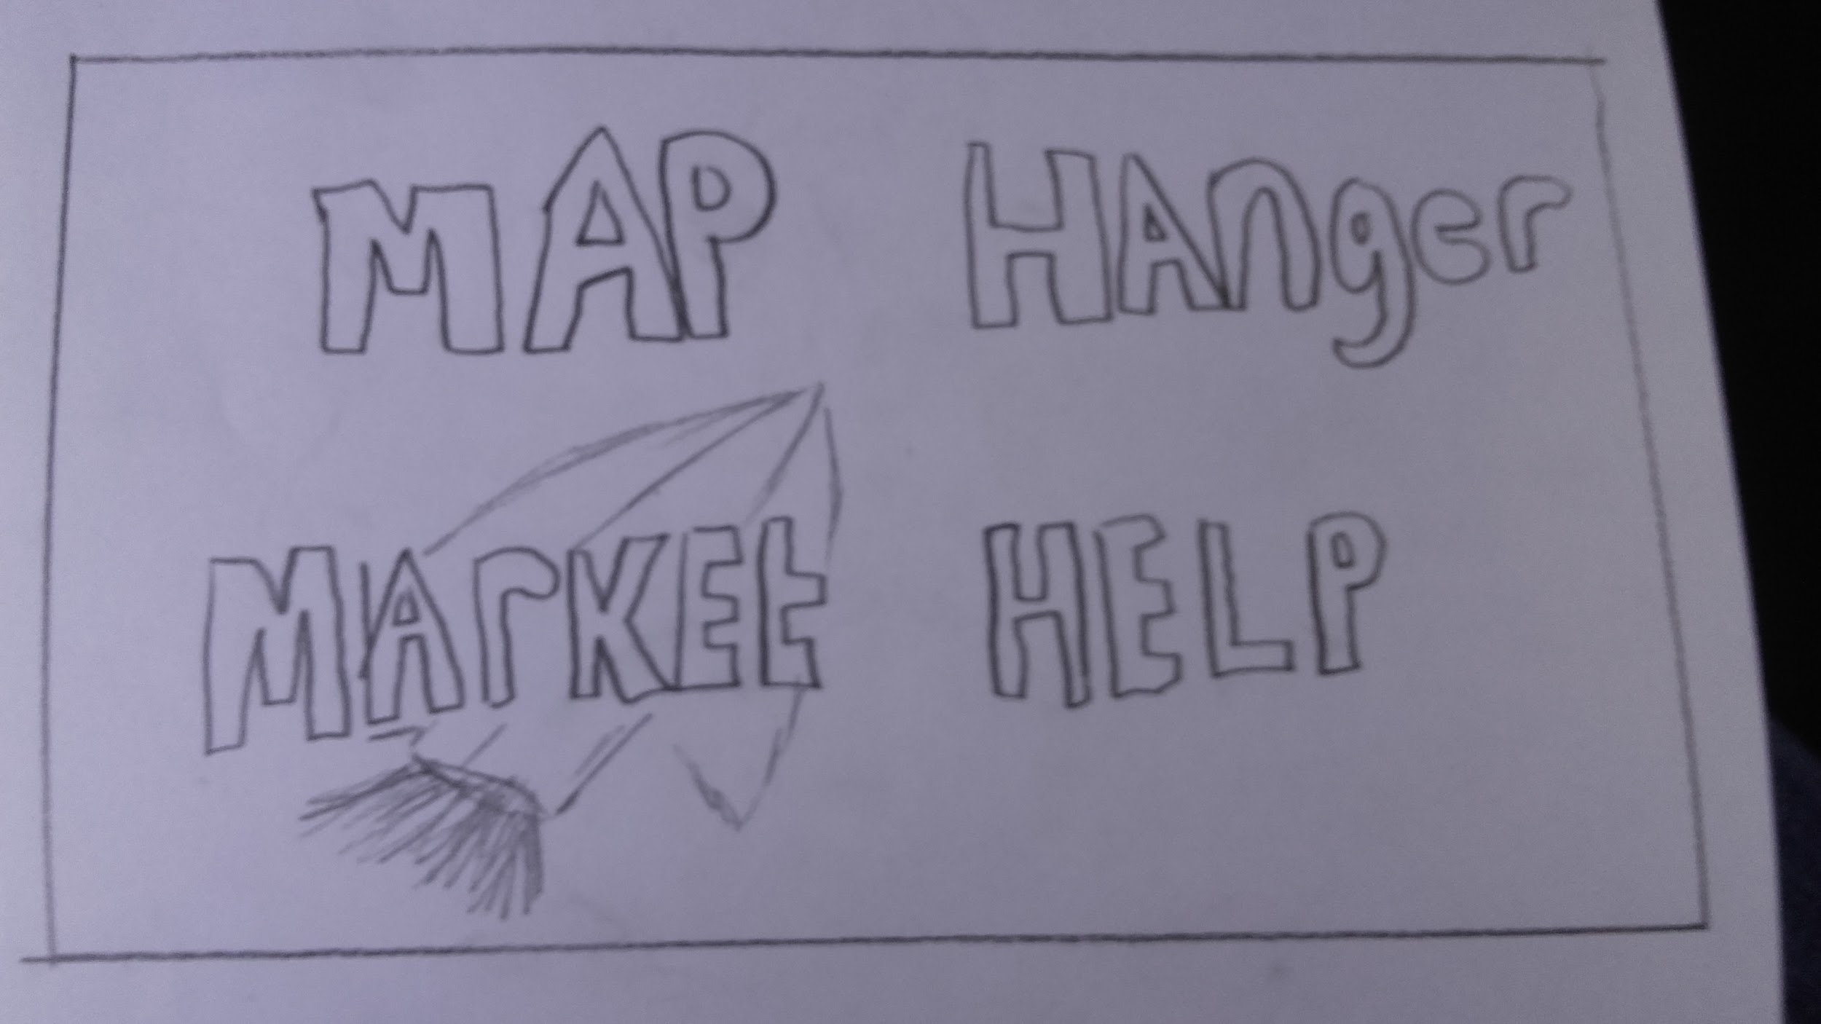

**4. Licence Screen:**

Display the developers, designers, time taken, and Made with SFML

**5. Splash screen:**

Same image that is used in the menu screen but with color

Will have “Press any button to start” dialogue on the middle foreground

Will have the name of the game and its creators

**6. Story:**

Individual screen that will update the story as planets are unlocked

Will have a prologue before starting and a epilogue when you unlock the last planet

**7. Planets:**

Will allow player to choose planet

Grayed out planets are locked

Will display the percentage drop rates of gems and appearance of enemy ships, each percentage will be unique to each planet

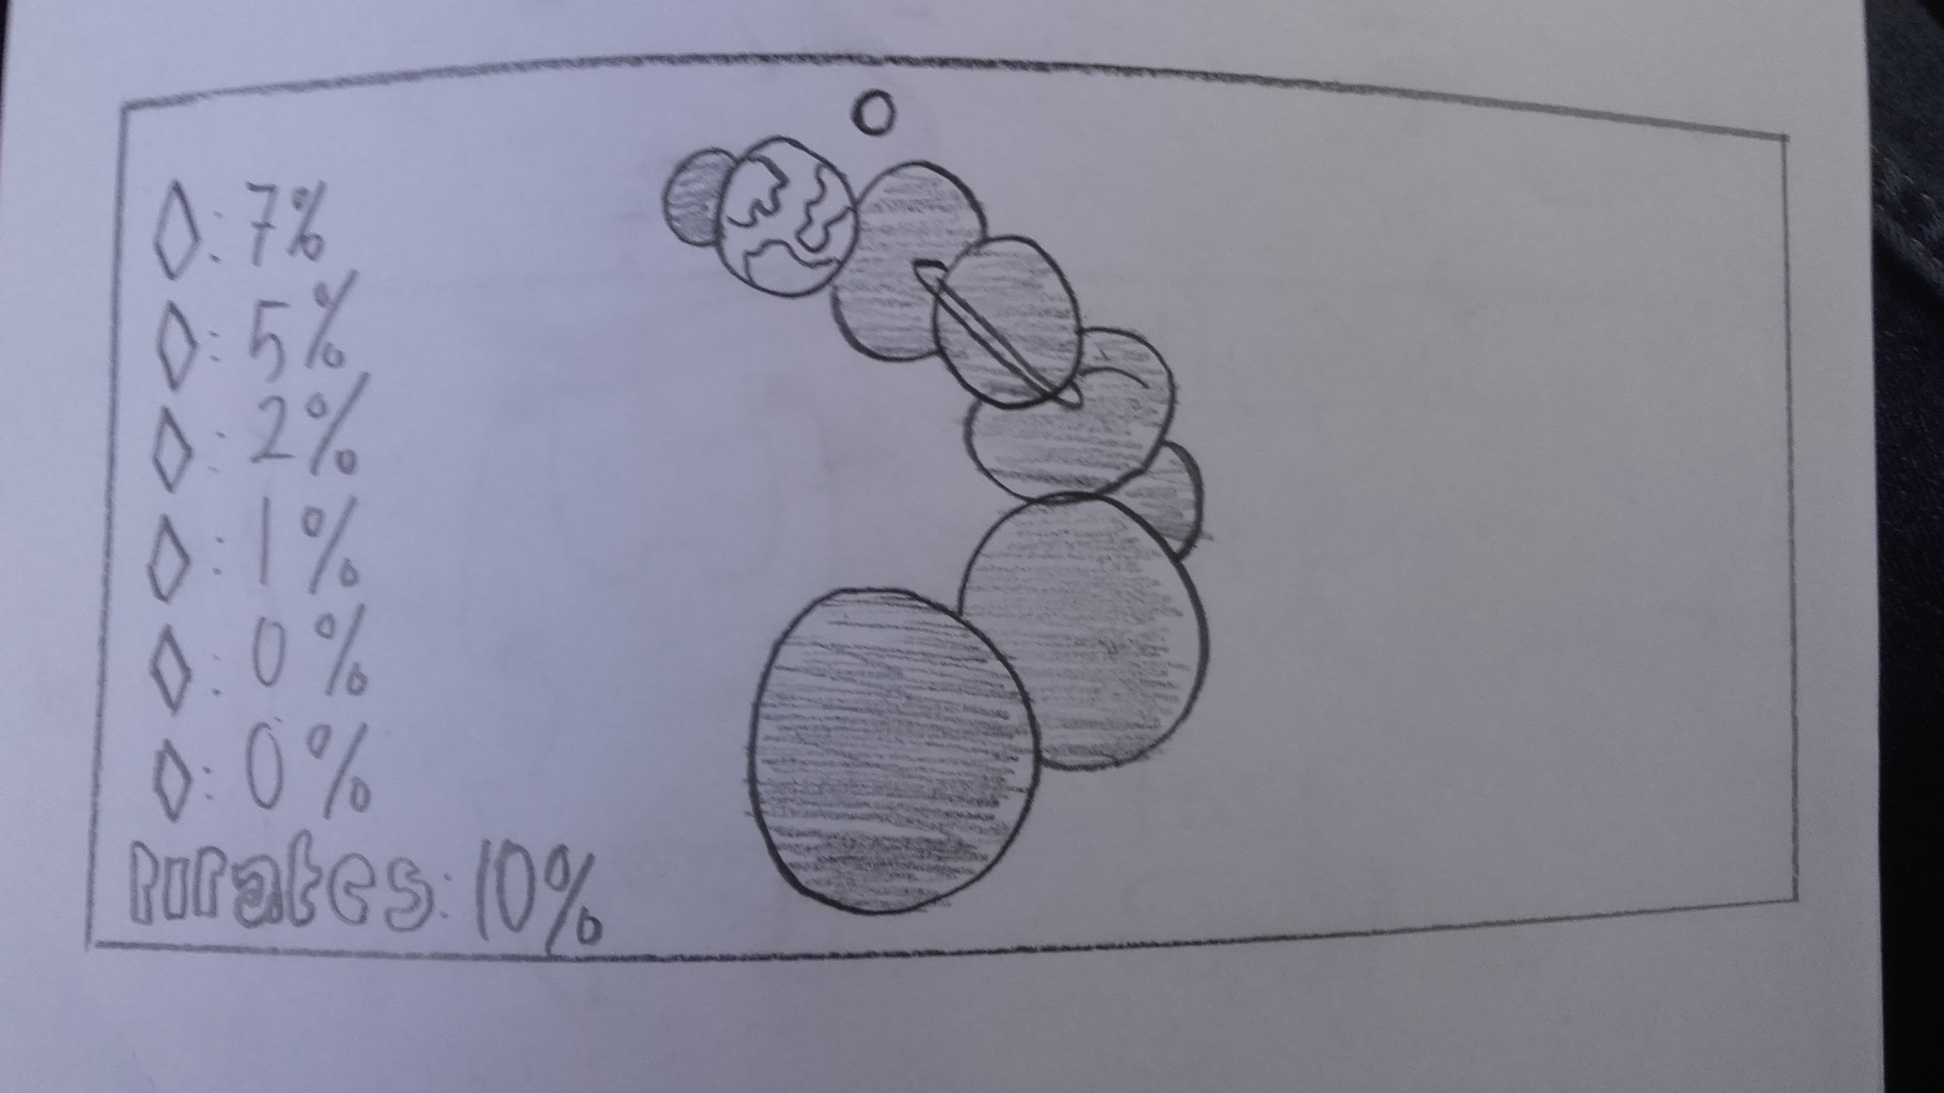

**8. Pause Screen:**

Re-commence play- Allow the user to resume play

Retreat to Base- Will allow the user to return to main menu

Go to hanger- Will allow the user to go to the upgrade section

**9. Exchange center:**

Exchange Gems for credits

Will have updated deals for the user after a deal is selected

